Talyllyn Gunpowder van

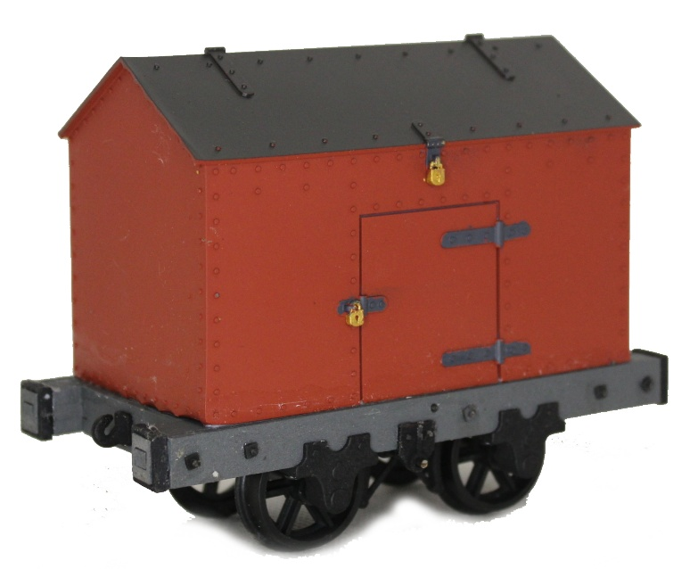
The Talyllyn railway used an iron bodied van to transport wooden barrels of gun powder from the powder shed at Wharf station up the line to various quarries. The van was of massive construction for security reasons; steel panels riveted to angle iron internal supports. Access was via a hinged roof and a small side door, both of which were kept padlocked.

A choice of couplings is included in this kit. You can either assemble the wagon with side “dumb buffers” and a central hook for a 3 link chain (see above) or if you prefer a centre buffer (for greater compatibility with the rest of your stock), a pair of Penrhyn style wagon buffers are also included (see below).
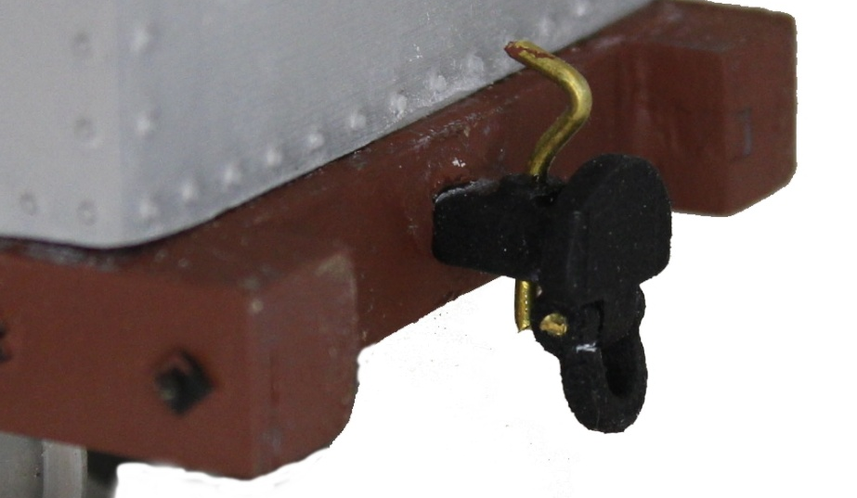
General Assembly Instructions
Do take time to read through the instructions and understand how the parts fit together before reaching for the glue pot. Pay particular attention to the orientation of the brake components
Gluing
The MDF parts may be glued with PVA wood glue, Cyanoacrylate adhesive (super-glue) or epoxy resin (Araldite). Beware of vary cheap glues, their joints may fail! If you do use a “super-glue”, go for one which takes a few seconds to set rather than an instant “grab” one. This will give you a few seconds to adjust the parts position before it is too late.
Nylon and Acrylate parts (e.g. corner plates and buffer strapping) are best fixed with good quality Cyano/super glue. We recommend the “Haffix” brand as this does not seem to cause the white “frosting” that some brands are prone to.

Painting
This is very much a matter of personal choice. As MDF is used for some parts of this model it is highly recommended that all these parts are either painted or protected with acrylic varnish, especially if you like to run your trains on rainy days. MDF is very absorbent so you will need several coats of whatever you choose. Small tins of exterior wood stain/varnish in a variety of colours are available from your DIY chain store.
The body (which is 3D printed resin) is less critical and can be simply painted with a wide variety on acrylic or enamel modelling paints.
All the nylon detail parts come pre-stained in a deep black colour. You may paint these parts if you require with enamel or acrylic model paints. Note that the surface of the nylon is slightly porous so you may find you first coat soaks in quite a lot.

Tools
The following tools will be required:
- A sharp modelling knife or scalpel
- A small file, sand paper or an emery board “nail file”
- A small “Philips” screw driver, size 0
- A pair of needle nosed pliers
- A 2mm and 3mm drill bits
The following tools are recommended
- A cutting matt
- A small steel ruler
- Some small clamps, bulldog clips or rubber bands
- Round and flat section “needle files”
- A metal working vice or a wood working vice
- A fine tipped black permanent marker pen.

Step 1 – Chassis
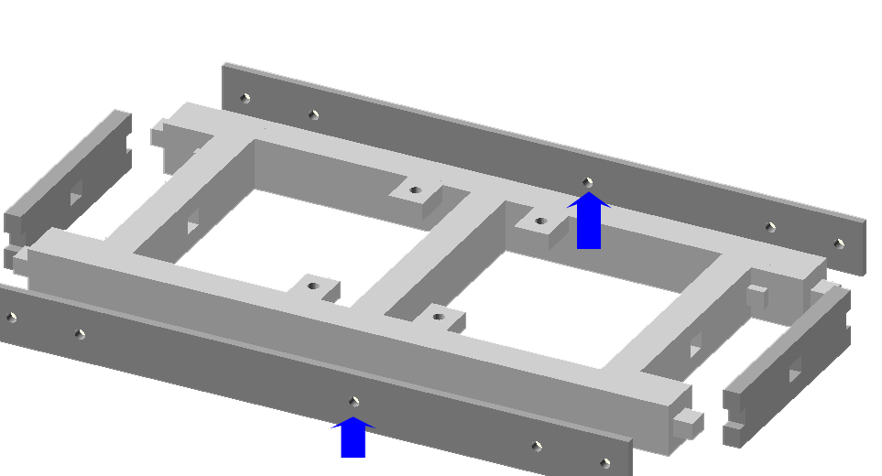
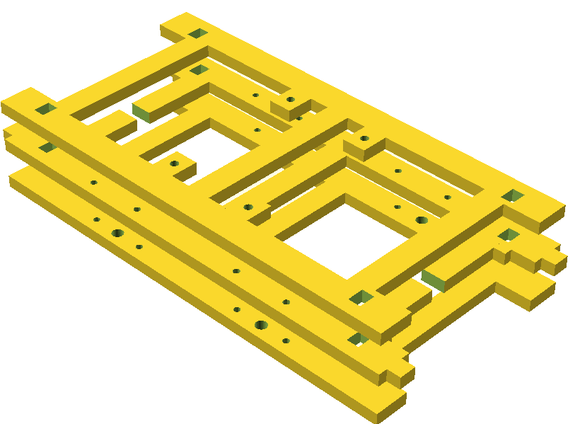
PVA wood glue is recommended for this step or if you want to use a super-glue DON’T use an “instant grab type”. Glue the 3 “chassis plates” together taking care to align the parts (the buffer mounting plates help with this). Note the sequence of axle box holes; small gab for buffer shank; and brake shoe sockets of the three plates. Make sure the parts are squeezed together properly. Wipe out any glue that oozes into the body end locating holes and buffer shank holes.
Now glue the two buffer mounting plates of your choice (see below) onto the ends between the two sole bar extensions. Clamp the parts together with small modeller’s clamps or bull dog clips while the glue sets.
Three pairs of buffer mounting plates are provided. A pair with a square socket for the supplied hook and Penrhyn style centre buffers. A pair with 2 holes 14mm apart for use with our bell mouth couplers (not supplied) and a plain pair for anything else we haven’t thought of.
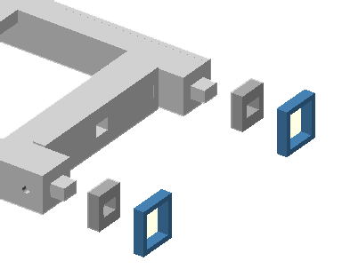
Glue the 1.5 mm side plates onto the chassis sides. If you intend to fit the square frame nuts then use the plates with the 5 holes. (N.B. the centre holes are a little offset from the centre. Both holes need to be at the same end of the chassis). If you rather not bother with the frame nuts then two plain chassis sides are provided
If you are intending to use our hook and chain couplers, glue the 4 small sole bar extensions onto their locating lugs and then the 3D printed buffer straps around them.
If you don’t intend to fit the dumb buffers and straps (i.e. you plan to use the Penrhyn centre buffers), cut off the 4 locating pegs with a razor saw or junior hack saw.

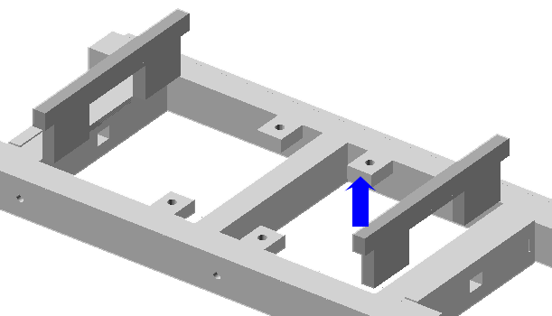

Glue the body locating lugs onto the inside faces of the chassis ends. N.B. the brake mounting lugs are at the top of the chassis.

Now paint or varnish the complete chassis assembly to seal it against moisture.
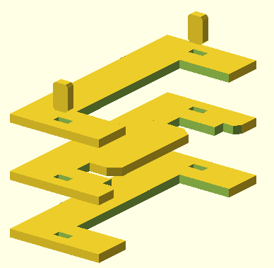

Step 2 – Axle Assemblies
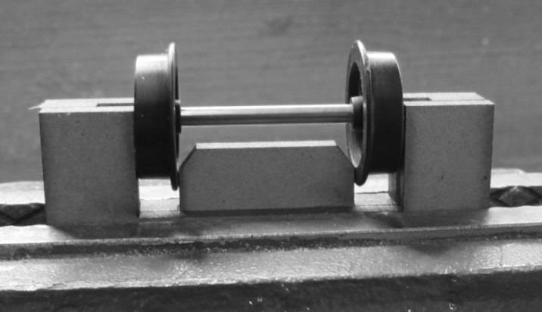
Glue the three parts of the wheel assembly jig together using two locating pegs to align them.

Once the glue is set, place the jig in your vice. Push a pair of wheels onto an axle and push them in from the ends about 6mm. Now manoeuvre the complete assembly into the jig as shown, gently moving the wheels in and out until it fits nicely.

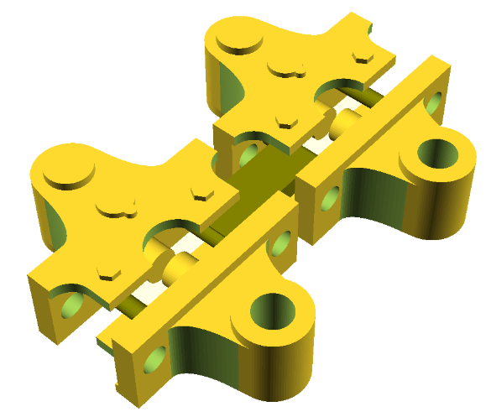
Step 3– Axle boxes
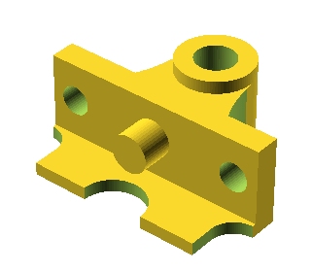
Cut the four 3D printed axle boxes from their connecting sprues (the dark grey bits in the picture to the right).
N.B. don’t trim off the round locating peg!

Clean out any printing dust in the axle holes by “twizzling” a 3mm drill bit in them.
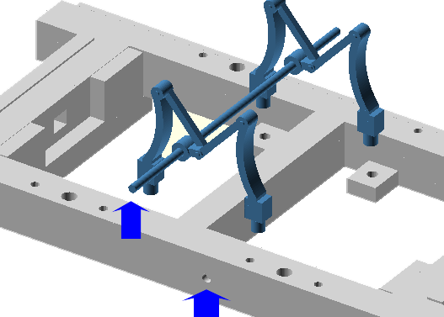
Step 4 – Brake Gear and Wheels
Thread the steel brake rod through the 2 holes in the 2 brake shoe pairs and glue the brake shoes into the chassis locating sockets. But don’t glue the brake rod yet
Note the orientation of the frame nut hole in the chassis side and the offset of the brake rod. The brake handle side of the chassis is shown at the bottom left of this picture (right).
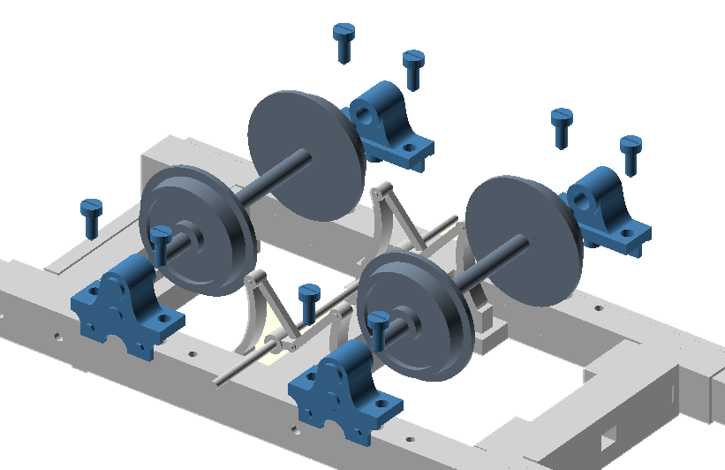

Place a pair of axle boxes onto an wheel set and fit the two locating pegs into their holes in the chassis. Now secure in place with 4 of the self tapping screws.
Repeat for the other end.

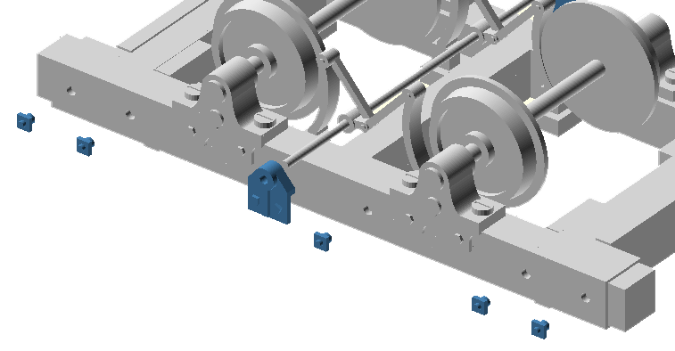
Before entering service, remember to oil the axle ends with a light lubricating oil (e.g. 3-in-1).
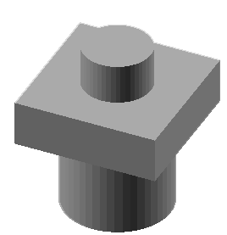
Now thread the 2 brake rod support plates onto the rod ends and glue to the chassis. The brake rod should be flush with the plate on the “non handle” side and protrude about 5mm on the handle side

Use a 2mm twist drill to clean out and deepen the locating holes in the chassis sides. Snip the “frame nuts” from their sprues (see left) and glue in these holes. We have provided plenty of spares!

Step 5 – Body
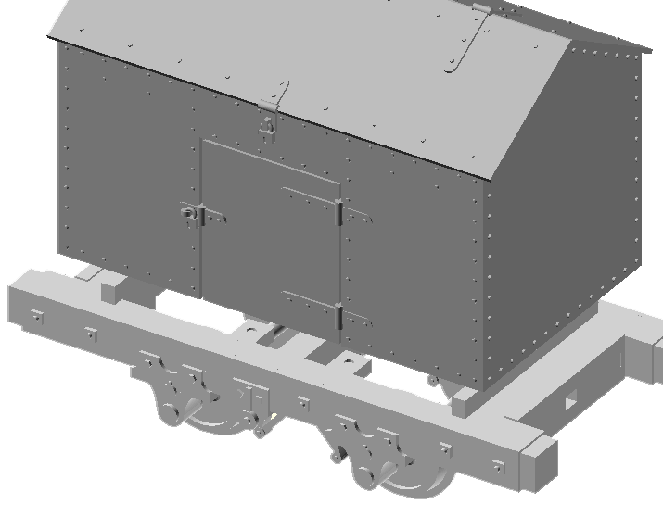
Glue the body to the top of the chassis. Make sure the brake rod protrudes on the plain (i.e. no door) side.

Step 6 – Couplers
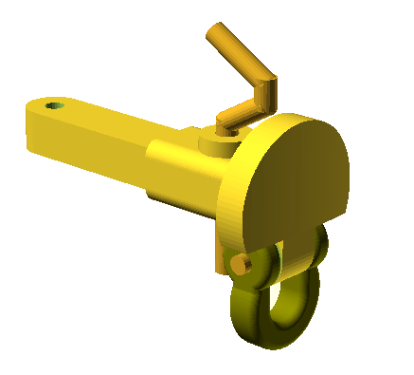
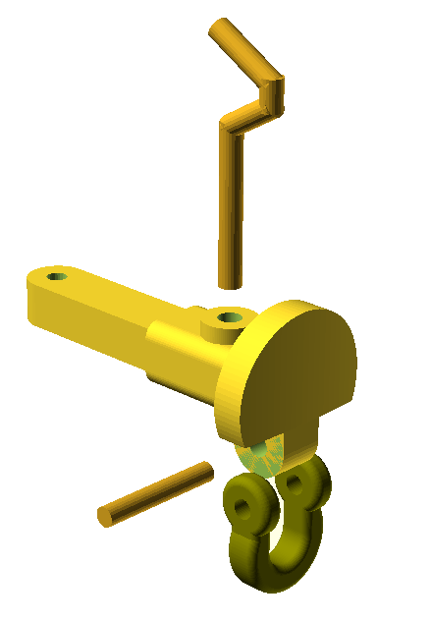
If you intend to use the Penrhyn buffers these will need assembling now. Cut two 8mm long sections from the supplied brass rod and attach the shackle to the buffer by pushing the rod through the eyes and body. Bend up 2 hooks with needle nose pliers and glue into the body as shown.

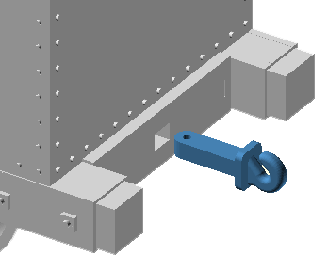

Now push the hook or buffer shank though the rectangular socket in the buffer beam and push a small (6mm) section of brass rod though the hole to fix in place.

Repeat for the other end

Step 7 – Brake Handle
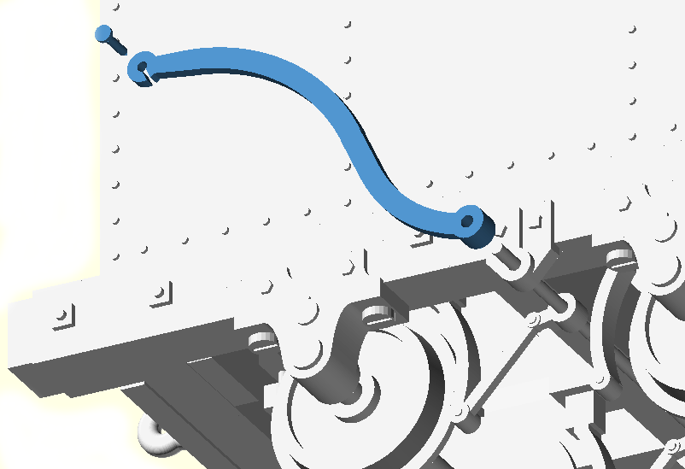
Push the brake handle onto the protruding brake rod. Position the handle at an angle that suits you then either simply secure with a drop of glue or drill a 1mm hole through the little eyelet into the body and then secure with a track pin and a spot of glue.

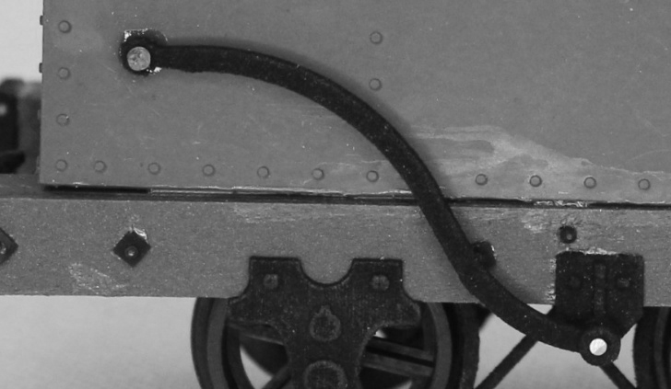

Job Done!

Packing List
Part | Quantity
Chassis side plates (1.5mm plywood) | 1
Chassis A (3mm MDF) | 1
Chassis B (3mm MDF) | 1
Chassis C (3mm MDF) | 1
Body locating lugs (3mm MDF) | 1
Wheel Setter (3mm MDF) Binnie wheel version only | 1
Van Body 3D printed resin | 1
Frame nut sprue 3D printed resin | 1
Bits Bag
Brake part set | 1
Dumb buffer strap set | 1
Buffer / hook set | 1
Brake rod (65mm long 1.5 mm dia piano wire) | 1
Coupling wire (75mm long 1.2 mm brass wire) | 1
Small nail / pin | 1
Coupling chain | 2
Wheel bag
Binnie 24mm web spoke wheels | 4
Axles (52mm long 3mm piano wire) | 2
Clover leaf axle box set | 1
M2 self tapper screws | 8
Tyre weight strip | 1

